Deepak Bhardwaj
deepakb@sdsol.ai
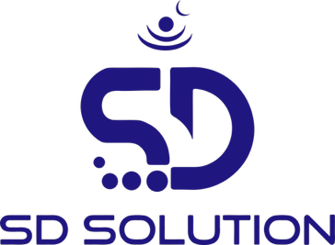
QDrishti – CBOM
Quantum Security Implementation Approach Crypto Bill of Material Analysis and Proposal

Table of Contents
Table of Contents 1
Context setting 2
Quantum Threat 2
Healthcare context 3
Key Findings for Healthcare & Life Sciences 4
Quantum Threat Landscape: Healthcare-Specific Implications 4
Shor’s Algorithm 4
Grover’s Algorithm 5
QCCPA (Quantum Computing Cybersecurity Preparedness Act) 5
What the Act Mandates (Plain English) 5
1. Inventory All Cryptography 5
2. Assess Quantum Vulnerability 6
3. Plan Migration to Post-Quantum Cryptography (PQC) 6
4. Align with NIST Standards 6
Executive Summary 6
What is CBOM? 7
Core CBOM Components 7
What Does a CBOM Contain? 7
Qdrishti 8
Core Capabilities 8
Architecture & Components 9
Core Components 9
Scanners 10
Prerequisites 11
GitHub Repository Scanning. 11
Local Source Code Scanning (ZIP/TAR Files). 11
Network Traffic Analysis (PCAP Files). 12
Dynamic Agent based Scanning for Run Time Applications (No Source Code) 12
Agent Deployment Requirements. 13
Qdrishti (Self-Hosted/On-premises Docker) Pre-requisites 13
Qdrishti Server Hardware Requirements: 13
Scope for the POC: 13
In-Scope 13
Out of Scope (Unless Explicitly Agreed) 14
Success Criteria 14
Implementation Plan 14
Implementation Phases 14
Phase 1: Initiation & Planning 14
Phase 2: Platform Deployment 15
Phase 3: Cryptographic Discovery & Analysis 15
Phase 4: Risk & Quantum Readiness Assessment 15
Phase 5: Reporting & Recommendations 15
Timelines 15
RACI Matrix 16
Duration & Milestones 16
Assumptions & Risks 16
Assumptions 16
Risks & Mitigation 16

Context setting
Cryptography is a requirement for confidentiality, integrity and authentic communication, and it is an indispensable technology used to protect data security.
Cryptography is important in that it allows people to experience the same level of trust and conﬁdence in the digital world as in the physical world. Today, cryptography allows millions of people to interact electronically via e-mail, E-commerce, ATMs, cell phones, etc. The continuous increase of data transmitted electronically has led to an increased need for and reliance on cryptography.
The four objectives of cryptography are:
- Conﬁdentiality—Data cannot be read by anyone for whom it was not intended.
- Integrity—Data cannot be altered in storage of transit between sender and intended receiver without the alteration being detected.
- Authentication—Sender and receiver can conﬁrm each other’s identity.
- Nonrepudiation—It is not possible to deny at a later time one’s involvement in a
cryptographic process.

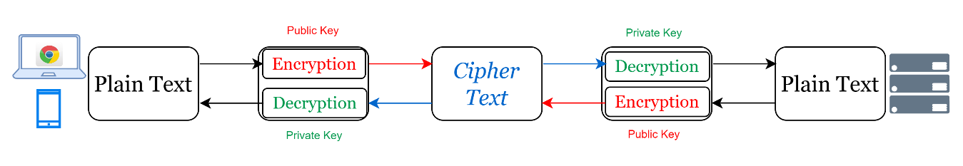
- Converts plaintext into ciphertext using algorithms and keys
- Ensures confidentiality, integrity, authentication, and non-repudiation

Quantum cryptography is an emerging field at the intersection of quantum mechanics and information security, offering innovative solutions to the forthcoming and existing challenge of secure communication under Quantum Computing threat. Unlike classical cryptographic methods, which rely on hard mathematical complexity like prime factorization to secure data, quantum cryptography utilizes the principles of quantum mechanics and mathematical complexity like lattice-based cryptography which are immune to computing power to provide unbreakable encryption.

Quantum Threat
Quantum threats in 2026 center on Harvest Now, Decrypt Later (HNDL) attacks, where adversaries actively collect encrypted data today for future decryption using cryptographically relevant quantum computers (CRQCs). No CRQCs exist yet, but intelligence confirms HNDL operations targeting critical sectors like finance, pharma, and energy.
Current security algorithms focus on data confidentiality, integrity, and authentication through symmetric encryption (shared keys) and asymmetric encryption (public/private keys). The industry standard for symmetric encryption is AES-128/256, while RSA and ECC (Elliptic Curve Cryptography) dominate asymmetric encryption. These are critical for protecting data in transit (SSL/TLS) and at rest.
The RSA, ECC/DH are widely used in TLS/SSL Certificates(https), VPN, Email, SSH, PKI (CA & Digital Signatures or ID’s), TLS 1.3 for Key Exchange, EC DSA used in Block Chain, HSM & 2 FA (Hardware Tokens)
These are the main encryption methods at risk from quantum attacks:
- RSA (all key sizes): Relies on integer factorization, directly broken by Shor's algorithm.
- ECC (Elliptic Curve Cryptography): Vulnerable due to elliptic curve discrete logarithm problem.
- Diffie-Hellman (DH) key exchange (including ECDH): Discrete logarithm problem solvable by quantum computers.
- DSA and ECDSA signatures: Same mathematical foundations as DH/ECC.
Grover's algorithm halves effective security bits (e.g., AES Advanced Encryption Standard and SHA-256.SHA-256 drops from 256-bit to 128-bit preimage resistance), but does not break them outright like Shor's algorithm breaks RSA/ECC.
Breach happens in the future, but theft happens today
Trust Now, Forge Later (TNFL), Future Collapse of Digital Trust
Digital identities and signatures created today can be:
- Forged later
- Impersonated
- Replayed

Healthcare context
The Healthcare and Life Sciences (HCLS) sector faces acute quantum cryptographic risk due to the extreme sensitivity and longevity of its data—electronic health records (EHRs), genomic data, medical imaging, clinical trial data, insurance eligibility, claims, and provider credentials—combined with stringent regulatory oversight (NIST, HIPAA, HITECH, FDA 21 CFR Part 11, DPDP Act, GDPR, ISO 27799, HITRUST CSF) and long-term confidentiality requirements (often 30–100 years, especially for genomic and pediatric records).
Quantum computers leveraging Shor’s algorithm will fundamentally compromise RSA and ECC, the asymmetric encryption standards currently protecting 95%+ of healthcare digital infrastructure, including:
- EHR platforms and patient portals
- Health Information Exchanges (HIEs)
- Provider-to-payer APIs (FHIR, HL7)
- Medical device authentication
- Digital signatures for prescriptions, lab results, and clinical trial data
- Public Key Infrastructure (PKI) securing healthcare identity and access
The “harvest now, decrypt later” (HNDL) threat—already being executed by nation-state and advanced persistent threat (APT) actors—poses a retroactive exposure risk for healthcare data that must remain confidential for decades. Encrypted patient data intercepted today can be decrypted in the future once cryptographically relevant quantum computers (CRQCs) become viable.
Healthcare organizations collectively store data on hundreds of millions of patients. Retroactive decryption would expose:
- Protected Health Information (PHI)
- Diagnoses, medications, lab results
- Genomic and biometric data
- Mental health and substance-use records
- Insurance eligibility and claims history
Such exposure would trigger severe regulatory penalties, class-action litigation, loss of patient trust, and irreversible reputational damage.
While symmetric encryption (AES-256) and modern hashing (SHA-3-512) remain quantum-resilient with appropriate parameters, the asymmetric layer of healthcare security is fundamentally broken in a post-quantum future. Importantly, NIST-standardized Post-Quantum Cryptography (PQC) algorithms are now production-ready, enabling healthcare organizations to begin migration immediately.
Regulators, standards bodies, and healthcare technology vendors are aligning toward crypto-agility by 2026 and PQC adoption by 2028–2030, particularly for patient identity, interoperability, medical devices, and regulated clinical systems.

Key Findings for Healthcare & Life Sciences
- RSA/ECC vulnerability impacts 70%+ of healthcare infrastructure, including:
  - EHR systems and patient portals
  - FHIR/HL7-based interoperability APIs
  - Health Information Exchanges (HIEs)
  - Medical device authentication and telemetry
  - Digital signing of prescriptions, lab reports, and clinical documents
- AES-256 remains secure against quantum threats; legacy AES-128 implementations must be upgraded immediately, especially in medical devices and archival systems
- NIST FIPS-approved PQC algorithms (ML-KEM, ML-DSA, SLH-DSA) are finalized and suitable for regulated healthcare workloads
- Hybrid TLS 1.3 + ML-KEM deployments are essential for:
  - Patient-facing applications
  - Provider-payer APIs
  - Telehealth platforms
  - Cloud-hosted EHRs and data lakes
- Business Impact:
  - Regulatory penalties under HIPAA, GDPR, DPDP, and global privacy laws
  - Retroactive exposure of lifelong patient data via HNDL attacks
  - Loss of patient trust, provider confidence, and partner ecosystem credibility
  - Increased cyber-insurance costs and reduced insurability

Quantum Threat Landscape: Healthcare-Specific Implications
The Cryptanalytic Threat and Healthcare Impact
Quantum computers exploit quantum mechanical properties—superposition and entanglement—to solve certain mathematical problems exponentially faster than classical systems. For healthcare, this introduces two primary cryptographic threats:

Shor’s Algorithm
Existential Threat to Healthcare Identity, Integrity, and Interoperability
- Breaks integer factorization and discrete logarithm problems in polynomial time
- Compromises:
  - RSA (all key sizes)
  - ECC
  - Diffie-Hellman
  - ECDSA / EdDSA
- Healthcare Sector Exposure:
  - EHR authentication and access control
  - Digital signatures on clinical records and prescriptions
  - Secure exchange of PHI via HIEs
  - Provider and device identity certificates
  - Blockchain-based clinical trial integrity and consent tracking
- Timeline:
  - Cryptographically relevant quantum computers estimated in 4–10 years
  - Healthcare data is already being harvested today due to its long-term value
- Impact:
  - Retroactive decryption of EHRs and clinical communications
  - Exposure of lifetime medical histories and genomic data
  - Compromise of clinical integrity and non-repudiation
  - Massive regulatory, legal, and ethical consequences

Grover’s Algorithm
Quadratic Threat to Symmetric Cryptography
- Affects:
  - Symmetric encryption (AES, ChaCha20)
  - Hash functions (SHA-256, SHA-3)
- Mitigation:
  - Straightforward and effective
  - Use AES-256 instead of AES-128
  - Use SHA-512 / SHA-3-512 instead of SHA-256
When properly configured, symmetric cryptography remains quantum-resilient for healthcare workloads.

QCCPA (Quantum Computing Cybersecurity Preparedness Act)
Govt readiness to repond quantum thread mandates cryptographic readiness.

What the Act Mandates (Plain English)

1. Inventory All Cryptography
Federal agencies must:
- Identify where encryption is used
- Identify which algorithms are used
- Identify which data must remain confidential long-term
➡️ For healthcare:
This is equivalent to building a Crypto Bill of Materials (CBOM) for:
- EHRs
- Patient portals
- Interoperability APIs
- Medical devices
- Data archives

2. Assess Quantum Vulnerability
Agencies must determine:
- Which systems rely on quantum-vulnerable cryptography
- Which systems protect high-value or long-lived data
➡️ For healthcare:
- PHI, genomic data, pediatric records, mental health records
- Clinical trial data and FDA-regulated systems
- Long-term archives and backups

3. Plan Migration to Post-Quantum Cryptography (PQC)
Agencies must:
- Develop a roadmap to migrate to NIST-approved PQC
- Prioritize high-risk systems
- Avoid “rip and replace” by enabling crypto-agility
➡️ For healthcare:
- Hybrid TLS (RSA/ECC + PQC) for patient-facing systems
- PQC-ready PKI for provider & device identity
- Future-proof cloud EHR platforms

4. Align with NIST Standards
The Act explicitly ties compliance to NIST PQC standards, including:
- ML-KEM (key exchange)
- ML-DSA (digital signatures)
- SLH-DSA (hash-based signatures)

Executive Summary
This document outlines a comprehensive approach to upgrade IT infrastructure to Quantum Safe with specific focus on Banking/Financial Services/Insurance (BFSI), Energy/Utilities, and critical infrastructure sectors. The strategy addresses technical integration methodologies, realistic time and cost estimates, measurable customer benefits, and sector-specific risk profiles.
Key deliverables:
- To upgrade current IT Infrastructure to Quantum Safe with minimum disruptions to existing setup.
- 12-36 months phased deployment timeline with effort estimates
- Healthcare, BFSI and Energy/Utilities sector-specific threat models and regulatory drivers

What is CBOM?
A Cryptographic Bill of Materials (CBOM) is a structured, machine-readable inventory that documents all cryptographic assets within software, systems, or infrastructure— cryptographic assets like algorithms, keys, certificates, protocols, libraries across software, networks, and infrastructure and dependencies.

Core CBOM Components
Essential Elements Captured:
- Algorithms: RSA-2048, ECDSA-P256, AES-GCM, SHA-256, etc. (with key sizes, modes)
- Certificates: X.509 chains, issuers, expiry dates, keyUsage extensions
- Keys: SSH keys, API keys, symmetric keys (with sizes, rotation policies)
- Protocols: TLS 1.3, IPsec suites, VPN profiles
- Libraries: OpenSSL 3.0+, BoringSSL, Crypto++ versions
- Usage Context: Which services/endpoints/code paths use each asset

What Does a CBOM Contain?
A CBOM typically includes:
1. Algorithm Inventory
- RSA
- ECC / ECDSA
- AES
- SHA
- Diffie-Hellman
- PQC algorithms (if any)
2. Protocol Usage
- TLS versions
- VPN tunnels
- SSH
- API encryption
- Messaging encryption
3. Key Information
- Key sizes
- Key lifetimes
- Rotation policies
- Certificate authorities
4. Application Mapping
Which cryptography is used by:
- Core banking apps
- APIs
- Cloud workloads
- Mobile apps
- IoT / OT devices
5. Risk Classification
- Quantum vulnerable (High risk)
- Legacy crypto (Medium risk)
- Quantum safe (Low risk)

Qdrishti
Qdrishti is CBOM analytics and migration platform that provides comprehensive inventory of Cryptographic assets used or deployed across IT landscape of an organization.
Qdrishti provides complete visibility into your cryptographic inventory through:
- 8 Comprehensive Scan Types - Static code, runtime network traffic, cloud infrastructure, certificates, secrets, log and config scanner,
- Unified CBOM Generation - CycloneDX 1.6 standard for crypto bill of materials
- Quantum Readiness Scoring - 0-100 assessment with compliance mapping (NIST/FIPs, SEBI CSCRF, CNSA 2.0, PCI-DSS, HIPAA, GDPR).
- 74+ Algorithm Intelligence Database - Threat assessment, migration timelines, quantum-safe alternatives.
- Enterprise Aggregation Platform - Multi-scan correlation, deduplication, centralized dashboards.

Core Capabilities
- Static Code Scanning
  - Languages Supported: Python, JavaScript/TypeScript, Java, Go, C/C++, Rust, Ruby, PHP, C#, Kotlin.
  - Detection: Quantum-vulnerable algorithms (DES, 3DES, MD5, SHA-1, RSA-1024, RC4, Blowfish).
  - Coverage: Function calls, library imports, configuration files, hardcoded keys.
- Runtime Network Analysis
  - Protocols: TLS/SSL, SSH, IPsec, HTTPS, WebSocket.
  - Detection: Weak ciphers (RC4, 3DES), TLS 1.0/1.1, insecure key exchange.
  - Modes: Live application monitoring, Docker container analysis, Kubernetes pod monitoring, PCAP file analysis.
- Cloud Infrastructure Discovery
  - Providers: AWS (KMS, ACM, Secrets Manager), Azure (Key Vault, App Service), GCP (Cloud KMS, Secret Manager).
  - Assets: Encryption keys, certificates, cryptographic configurations.
  - Analysis: Key rotation status, algorithm strength, compliance violations.
- Certificate & Key Discovery
  - Scope: Filesystem scanning, Kubernetes secrets, Docker volumes, system keystores.
  - Detection: Expired certificates, weak signatures (MD5, SHA-1), private key exposure.
  - Tracking: Certificate chains, expiration timelines, renewal recommendations.
- CBOM Generation
  - Format: CycloneDX 1.6 (industry standard).
  - Content: Algorithm inventory, quantum threat assessment, migration timelines.
  - Integration: SBOM aggregation, dependency tracking, cryptographic relationships.
  - Component inventory with quantum vulnerability metadata
- Compliance & Policy
  - Standards: NIST/FIPs, SEBI CSC RF, CNSA 2.0.
  - Enforcement: Open Policy Agent (OPA) integration.
  - Reporting: Automated compliance reports, audit trails, policy violations.
- Quantum Readiness Assessment
  - Scoring: 0-100 based on algorithm strength, deployment coverage, migration readiness.
  - Uses Mosca’s Inequality to derive a quantitative, actionable risk score for post-quantum cryptography (PQC) migration.
  - Intelligence: 74+ algorithm threat profiles with quantum attack vectors.
  - Recommendations: Prioritized remediation roadmap with timeline projections.
- Production Security
  - Hardening: Command injection protection, path traversal prevention, input validation.

Architecture & Components
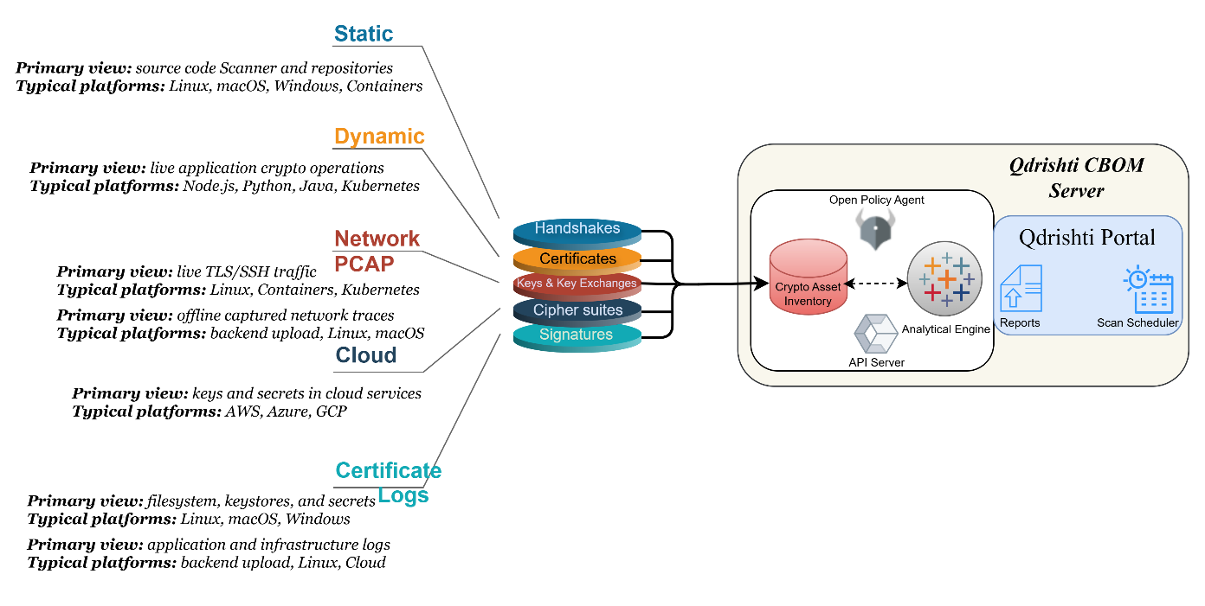

Core Components
- Scanner CLI (`Qdrishti`)
  - Purpose: Command-line interface for ad-hoc and CI/CD scanning.
  - Deployment: Local developer machines, CI/CD pipelines, containers.
  - Output: JSON/HTML reports, CBOM files, compliance reports.
- Scanner Agent (`Qdrishti_agent`)
  - Purpose: Persistent agent for scheduled enterprise scans.
  - Features: Auto-registration, heartbeat monitoring, scan queue processing.
  - Deployment: On-premises servers, cloud VMs, Kubernetes pods.
- Backend API (`Qdrishti_backend`)
  - Purpose: Centralized aggregation and analysis platform.
  - Technology: FastAPI, PostgreSQL, SQLAlchemy, Alembic migrations.
  - Features: Multi-tenant, REST API, authentication, audit logging.
- Dashboard UI
  - Purpose: Executive and technical visibility into cryptographic posture.
  - Technology: React, Vite, Chart.js, TailwindCSS.
  - Features: Real-time updates, drill-down analysis, export capabilities.
- Open Policy Agent
OPA is a policy engine that streamlines policy management across your stack for improved development, security and audit capability.

Scanners
What discovery scanners required to get a complete CBOM for an enterprise
An enterprise cannot get a “complete” CBOM from a single scanner; it needs a coordinated set of discovery capabilities covering code, binaries, infrastructure, and network traffic, all normalized into a standard like CycloneDX CBOM.
Static Code Scanner - Deep Dive: The Static Code Scanner performs comprehensive analysis of source code without execution, identifying cryptographic vulnerabilities in application code.

Dynamic/Runtime Analysis Scanner: The Dynamic Scanner monitors running applications to detect actual cryptographic operations at runtime, capturing real-world crypto usage patterns.

Network Traffic Scanner: The Network Traffic Scanner analyzes network communications to identify weak cryptographic protocols and insecure key exchange mechanisms.

Cloud Infrastructure Scanner: The Cloud Infrastructure Scanner discovers cryptographic assets across cloud providers and assesses their security posture.
Certificate & Key Discovery Scanner: The Certificate Scanner performs comprehensive discovery and analysis of X.509 certificates and cryptographic keys across the entire infrastructure.

Secrets & Configuration Scanner: The Secrets Scanner identifies hardcoded secrets, sensitive configurations, and credential mismanagement patterns.

Hybrid & Cross-Scanner Analysis: The Hybrid Scanner correlates findings across multiple scanner types to provide comprehensive cryptographic assessment.
Scanner Flow
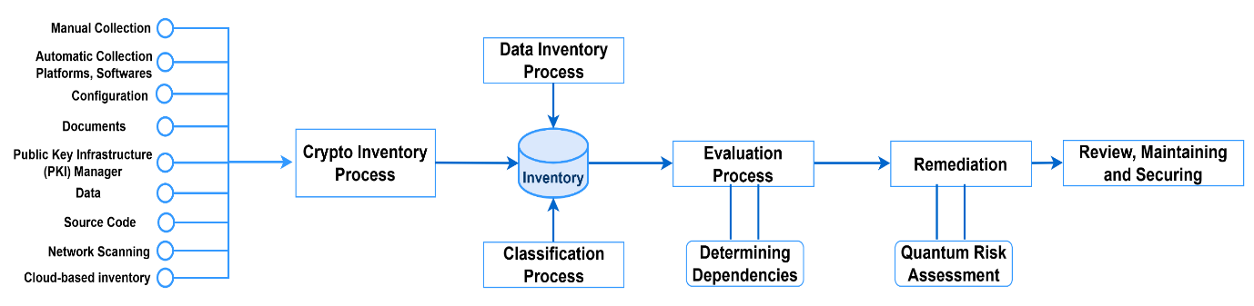
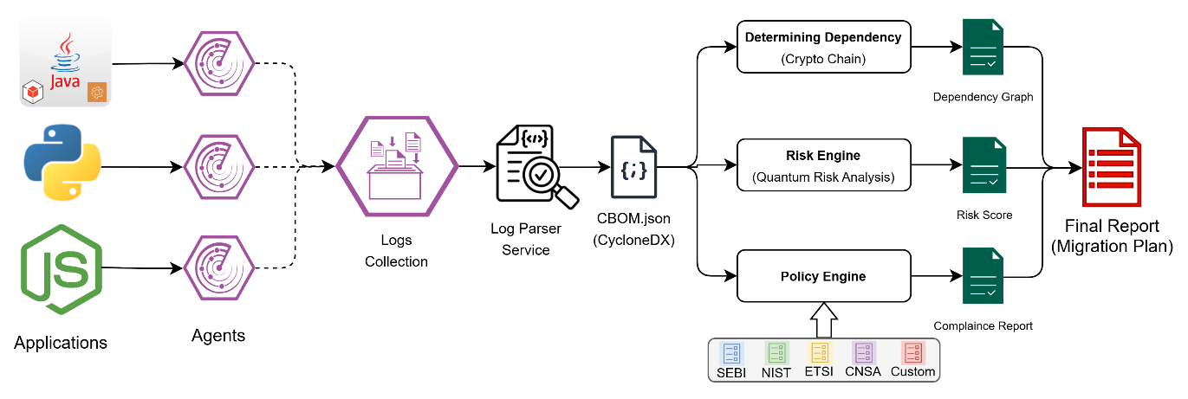
Fig: Example Dynamic Scanner for App

Prerequisites
Scanners

GitHub Repository Scanning.
GitHub Token Requirements
Token Type: Personal Access Token (PAT) or GitHub App installation token
Creation Steps:
  - Navigate to GitHub Settings → Developer settings → Personal access tokens
  - Click "Generate new token (classic)" or "Generate new fine-grained personal access token"
Select scopes:
- `repo` - Full repository access (recommended for private repos)
- `public_repo` - Public repository access only
- `admin:repo_hook` - For webhook integration (optional)
- `read:org` - Organization member access (optional)
Repository Clone Link Format
- HTTPS Format: `https://github.com/owner/repo-name.git`
- SSH Format: `git@github.com:owner/repo-name.git` (requires SSH key setup)
- GitHub CLI Format: `gh repo clone owner/repo-name`

Local Source Code Scanning (ZIP/TAR Files).
ZIP File Requirements
Supported Formats:
  - Standard ZIP (.zip)
  - Password-protected ZIP (with passphrase)
  - Nested/archive-in-archive structures
  - Compressed formats: Store, Deflate, Bzip2, LZMA
File Size Limits:
  - Single file limit: 2 GB (configurable)
  - Total archive limit: 10 GB (configurable)
  - Memory usage: ~100MB per 1GB of extracted data

Network Traffic Analysis (PCAP Files).
PCAP File Requirements
Supported Formats:
  - PCAP (libpcap standard format)
  - PCAPNG (next-generation PCAP)
  - GZIP-compressed PCAP (.pcap.gz)
  - Multiple concatenated PCAP files
File Size Support:
  - Single file: Up to 100 GB
  - Memory-efficient streaming (no full file load)
  - Disk cache for multi-pass analysis
Capture Requirements:
  - Network interface with promiscuous mode support
  - Sufficient buffer to prevent packet loss
  - BPF (Berkeley Packet Filter) for traffic filtering
All containers
PCAP Permissions & Capabilities
- Linux Requirements:
- CAP_NET_RAW`: Raw socket access for packet capture
- `CAP_NET_ADMIN`: Network administration capability
- Or run as root with `sudo`

Dynamic Agent based Scanning for Run Time Applications (No Source Code)
This agent observes runtime cryptographic usage in Java applications by instrumenting the JCA/JCE SPI layers.
1. Supported Runtime Environments
Java Runtime (mandatory)
Java version: 8 or higher
Recommended: Java 11, 17, or 21 (LTS)
JVM: HotSpot / OpenJDK
Operating Systems: Linux, macOS, Windows
Not supported
Android (ART)
GraalVM Native Image
AOT-compiled JVMs
2. Application Requirements
Application must run on the JVM
JVM must be startable with the -javaagent option
3. Required Agent Artifacts
Customers must have access to the following files:
spi-trace-agent.jar
byte-buddy.jar (version 1.14.x)
Both files must be readable by the JVM process.

4. JVM Startup Permissions
The agent must be attached at JVM startup.
Requirement
Ability to modify the JVM startup command
Example
-javaagent:/path/spi-trace-agent.jar
Dynamic (post-start) attachment is not supported.

Agent Deployment Requirements.
Agent System Requirements
- Operating System: Linux, Windows, macOS
- Python Version: Python 3.11+
- Memory: 2-4 GB RAM minimum
- Disk Space: 500 MB minimum
- Network: Outbound HTTPS to backend API

Qdrishti (Self-Hosted/On-premises Docker) Pre-requisites

Qdrishti Server Hardware Requirements:
# |  | Application | CPU | RAM | Disk | Internet | Port & Access
1 | Qdrishti Server |  | 8 CPU | 256 GB | 512 GB | Required | OS: Ubuntu 24+
- Internet: Internet access for Qdrishti Server during implementation and upgrading or applying patches
- Ports: 443 TCP

Scope for the POC:
The scope of this Proof of Concept (PoC) engagement is to establish end-to-end cryptographic visibility across selected applications and infrastructure, assess quantum vulnerability exposure, and provide a fact-based PQC migration roadmap.

In-Scope
- Source code analysis
- Network Analysis
- Hardware Security Module (HSM)

- Deployment of Qdrishti PoC environment (On-Prem / Self-Hosted Docker)
- Execution of agreed scan types, including:
  - Static code analysis (for provided sample applications)
  - Runtime network analysis (for sample scenarios)
  - Cloud cryptographic asset discovery (for the provided assets)
- Generation of Cryptographic Bill of Materials (C-BoM) in CycloneDX1.6 format
- Identification of:
  - Quantum-vulnerable algorithms
  - Weak cryptographic configurations
  - Non-migratable / legacy crypto dependencies (Custom)
- Delivery of:
  - Quantum Readiness Score
  - Risk and compliance reports
  - High-level PQC migration recommendations
- Plan and recommendations for next steps

Out of Scope (Unless Explicitly Agreed)
- Production environment changes
- Application source code remediation
- Cryptographic library replacement in live systems
- Regulatory filing or audit sign-off
- Dynamic Analysis

Success Criteria
The PoC will be considered successful when the following outcomes are achieved:
- Visibility into cryptographic algorithms used by in-scope systems
- Generation of a CBOM
- Clear classification of:
  - Quantum-safe vs quantum-vulnerable algorithms
  - Migratable vs non-migratable cryptographic assets
- Delivery of a quantified Quantum Readiness Score
- Actionable PQC migration roadmap aligned to NIST standards
- Executive-ready reports consumable by:
  - Security leadership
  - Risk & compliance teams

Implementation Plan

Implementation Phases
The PoC will be implemented in a phased approach working in close collaboration with the Sentara team.

Phase 1: Initiation & Planning
- Finalize PoC scope and applications
- Define scan permissions and access requirements
- Infrastructure readiness validation

Phase 2: Platform Deployment
- Deploy Qdrishti server (Docker / On-Prem)
- Configure scanning modules
- Validate connectivity and access

Phase 3: Cryptographic Discovery & Analysis
- Execute agreed scan types
- Correlate cryptographic findings
- Generate unified CBOM

Phase 4: Risk & Quantum Readiness Assessment
- Apply quantum threat intelligence
- Compute Quantum Readiness Score
- Identify priority risk areas

Phase 5: Reporting & Recommendations
- Deliver technical and executive reports
- Conduct stakeholder walkthrough
- Discuss next-phase migration strategy

Timelines
Following is a high-level timeline based on the current visibility, a detailed implementation plan and revised timeline will be prepared as requirements and dependencies are discovered.
Six Weeks
Deliverable | W1 | W2 | W3 | W4 | W5 | W6 | W7 | W8
Initiation & Planning
Finalize PoC scope and applications | 1
Define scan permissions and access requirements |  | 1
Infrastructure readiness validation |  | 1
Platform Deployment
Deploy Qdrishti server (Docker / On-Prem) |  |  | 1
Configure scanning modules |  |  |  | 1
Validate connectivity and access |  |  |  | 1
Cryptographic Discovery & Analysis
Execute agreed scan types |  |  |  | 1 | 1
Correlate cryptographic findings |  |  |  |  | 1
Generate unified CBOM |  |  |  |  |  | 1
Risk & Quantum Readiness Assessment
Apply quantum threat intelligence |  |  |  |  |  | 1
Compute Quantum Readiness Score |  |  |  |  |  | 1
Identify priority risk areas |  |  |  |  |  |  | 1
Reporting & Recommendations
Deliver technical and executive reports |  |  |  |  |  |  |  | 1
Conduct stakeholder walkthrough |  |  |  |  |  |  |  | 1
Discuss next-phase migration strategy |  |  |  |  |  |  |  | 1

RACI Matrix
Activity | Client Security Team | Client App Team | Qdrishti Team
PoC Scope Definition | R | A | C
Infrastructure Provisioning | R | A | C & I
Qdrishti Deployment | C | C | R
Scan Execution | C | R | A
CBOM Generation | I | C | R
Risk & Quantum Assessment | I | C | R
Final Reporting | I | C | R
R = Responsible | A = Accountable | C = Consulted | I = Informed

Duration & Milestones
Following are indicative milestones, details will be carved out working with Client team as per their priorities.
Milestone | Description | Timeline
M1 | PoC Kick-off & Scope Freeze | End of Week 2
M2 | Platform Deployment Complete | End of Week 4
M3 | Cryptographic Scans Completed | End of Week 7
M4 | CBOM & Risk Reports Generated | End of Week 9
M5 | Final Readout & Next-Steps | End of Week 10

Assumptions & Risks

Assumptions
- Required system access is provided on time
- Selected applications are representative of enterprise crypto usage
- No production traffic disruption during scanning
- Stakeholder availability for review sessions
- The permissions required for Dynamic Scanning will change based on the tech stack of the application
- No Custom Regulatory compliance will be considered.
- The Start date of the POC should be considered from date of Provisioning or providing all the prerequisites.
- Request Customer to raise all the required change requests for Network, source code and application permissions as required.

Risks & Mitigation
Risk | Impact | Mitigation
Limited scan access | Partial visibility | Early access validation
Unsupported algorithms | Delayed PQC roadmap | Alternative compensating controls
Infrastructure constraints | Scan delays | Flexible deployment options
Unexpected delays due to unforeseen issues | Timeline delays | Team will be working in a sprint model where scope and work can be prioritized based on client priorities.

